, CPráctica 1. Listar todos los alumnos
Dada la Base de datos bd_alumnos.
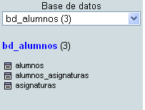
TABLA ALUMNOS TABLA ALUMNOS_ASIGNATURAS
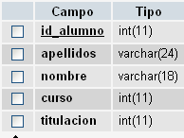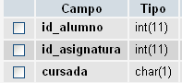
TABLA ASIGNATURAS
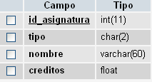
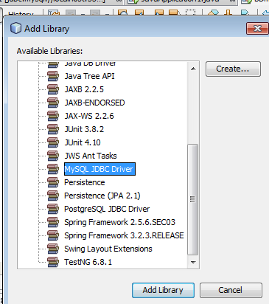
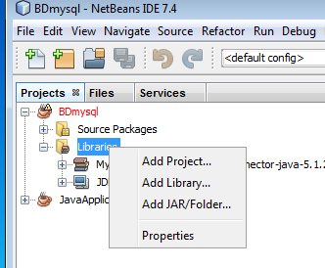

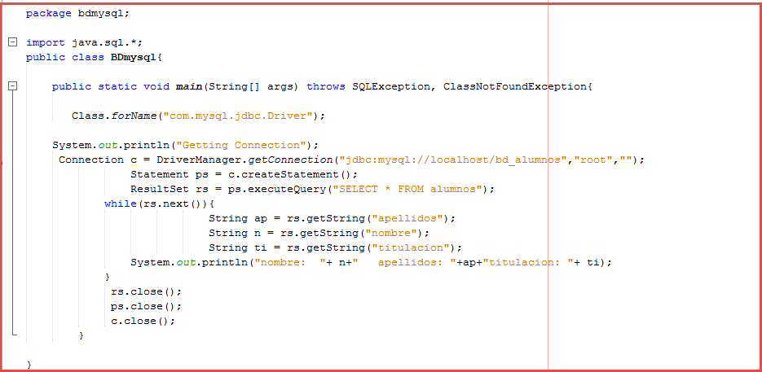
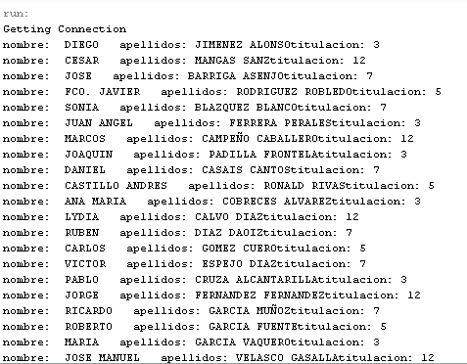

package bdmysql;

import java.sql.*;
public class BDmysql {

public static void main(String[] args) throws SQLException, ClassNotFoundException{
Class.forName("com.mysql.jdbc.Driver");

System.out.println("Getting Connection");
Connection c = DriverManager.getConnection("jdbc:mysql://localhost/bd_alumnos", "root", "");
Statement ps = c.createStatement();
ResultSet rs = ps.executeQuery("select * from alumnos");

while (rs.next()) {
String ap = rs.getString("apellidos");
String n = rs.getString("nombre");
String ti = rs.getString("titulacion");

System.out.println("nombre: " + n + " apellidos: " + ap + " titulacion: " + ti);
}
rs.close();
ps.close();
c.close();

}

}
